|  |
| --- |
| The Unsung Hero of Online Business: VoIP Phone Systems - Vivant Business  Phone Systems |
|  |
| voip and FXOMade by: - Akshat Kansal |
| **CCNP lab 5 – Mr. Mason & Mr. Hansen** **Periods 0,1,2** |

**Purpose**

In addition to data, networks can also facilitate the routing of voice communication. This is achieved through the use of Voice over IP (VoIP) technology, which allows for voice samples to be transmitted over the internet, rather than traditional copper phone lines. The focus of this lab was not only to configure VoIP, but also to explore various options for allowing VoIP phones to access analog lines and make calls through them. This could be done through the use of FXO/FXS gateways which allows analog phones to connect to a VoIP network and make calls through the internet or through the use of PSTN gateways that allows VoIP phones to connect to the Public Switched Telephone Network (PSTN) and make traditional phone calls. This lab provided an understanding of how VoIP can be used for voice communication and how it can be integrated with traditional phone systems to increase the functionality of the network.

**Background Information**

Voice over IP (VoIP) is a technology that enables phone calls to be made over the internet. It works by converting voice into digital signals, which are then transmitted over the internet and converted back to voice on the receiving end. This is a cost-effective method of calling as it does not require the installation of traditional copper phone lines, as the internet is used as the medium for data transfer.

In this lab, we focused on using VoIP in a local area network (LAN) environment, however, it is also possible to make calls across a wide area network (WAN) using h.323 standards. H.323 is a standard that defines the signaling and control messages used in VoIP and is commonly used in conjunction with SIP or SCCP and MGCP.

The signaling and control of voice and video calls in this lab was achieved using SCCP (Skinny Call Control Protocol), which is Cisco proprietary protocol. SCCP is often used in conjunction with RTP and RTCP to transmit audio and video over IP networks. It can be used with either Cisco Unified Communication Manager (CUCM) or Cisco Unified Communication Manager Express (CUCME). The main difference between SIP and SCCP is that SCCP is Cisco proprietary.

In this lab, we used Cisco Unified Communication Manager Express (CUCME) to enable VoIP. CUCME is a software-based IP private branch exchange (PBX) system that runs on Cisco routers, making it convenient for small to medium-sized businesses as it eliminates the need for a dedicated server to run CUCM.

The phones in this lab were easy to configure as they only needed to be plugged into a Power over Ethernet (PoE) switch. This was achieved through the use of Trivial File Transfer Protocol

**Lab Summary**

In this laboratory exercise, we established a local area network (LAN) connection between two Cisco VoIP phones, allowing them to make calls to each other using Voice over IP (VoIP). One of the phones was a 7940 model, and the other was a 7960 model. This was achieved by utilizing Cisco Unified Communication Manager Express (CUCME), also known as Cisco Unified Communication Manager (CUCM) Express, on a Cisco 2811 router with FXO voice cards. The router was used to run CME and transfer calls from VoIP to analog.

A Power over Ethernet (PoE) switch was used to provide power to the VoIP phones and create routes to the internet. Two computers were connected to the phones and configured with DHCP, allowing them to access the internet. The lab was considered successful when the computers were able to access the internet, the Cisco phones were able to contact each other through VoIP, and a call was able to be made from the Cisco phone to a cell phone. This was tested by placing a call to a local pizza delivery place and ordering a pizza. The ability to access the internet, make VoIP calls and make analog calls shows the versatility and flexibility of the network and the capability of the technology.

**Lab Commands**

ip dhcp excluded-address 192.168.20.1 192.168.20.5

ip dhcp pool VOICE20

   network 192.168.20.0 255.255.255.0

   default-router 192.168.20.1

   option 150 ip 192.168.20.1

interface FastEthernet0/0

 ip address dhcp

interface FastEthernet0/0.20

 encapsulation dot1Q 20

 ip address 192.168.20.1 255.255.255.0

tftp-server P00308000500.sbn

tftp-server P00308000500.loads

tftp-server flash:P00308000500.bin alias P00308000500

tftp-server flash:P00308000500.sb2

voice-port 1/0/0

 ring number 3

 connection plar opx 1010

 caller-id enable

dial-peer voice 83 pots

 destination-pattern 91[2-9]..[2-9]......

 port 1/0/0

 forward-digits all

telephony-service

 max-ephones 2

 max-dn 2

 ip source-address 192.167.20.1 port 2000

 auto assign 1 to 2

 system message ad astra per aspera

ephone-dn  1

 number 1010

ephone  1

mac-address 001D.A219.FA62

 type 7940

 button  1:2

**Network Diagram**

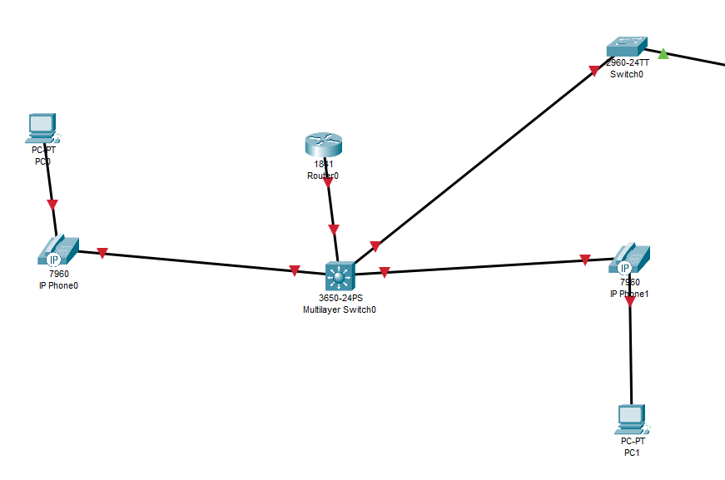

**Process**

In order to establish a network similar to the one shown in the Network Diagram, a Cisco 2811 Router was used to run Cisco Unified Communication Manager Express (CUCME) and a Power over Ethernet (PoE) switch was used to provide power to the IP phones. The computers connected behind the IP phones should be able to receive an IP address at this point, when set as DHCP clients.

Before proceeding with the configuration, it is important to confirm that the router has CUCME in its flash memory. This can be done by using the command "show flash:" in the router's command line interface (CLI). In this case, the CME files were not found in the router's flash memory, so a connection was established between the computer and a TFTP server, a CME tar file was copied into the router using the command "copy tftp://10.0.0.2/ flash:(file-name)" and extracted in the router's flash memory using the command "archive tar /extract (file name) flash:".

One aspect that could not be accurately modeled in the Network Diagram section was the connection of the FXO port. The Cisco 2811 router was equipped with FXO port voice interface cards which were connected to an analog line using an RJ11 jack. These FXO ports allow the router to connect to an analog phone line and make or receive PSTN calls. This addition allows the network to provide both VoIP and PSTN services, adding more flexibility and versatility to the network.

**Router**

hostname Router

boot-start-marker

boot-end-marker

logging message-counter syslog

no aaa new-model

memory-size iomem 10

no network-clock-participate slot 1

dot11 syslog

ip source-route

no ip cef

ip dhcp excluded-address 192.168.20.1 192.168.20.5

ip dhcp pool VOICE20

   network 192.168.20.0 255.255.255.0

   default-router 192.168.20.1

   option 150 ip 192.168.20.1

no ipv6 cef

multilink bundle-name authenticated

voice-card 0

 no dspfarm

voice-card 1

 no dspfarm

vtp domain cisco

vtp mode transparent

archive

 log config

  hidekeys

vlan 20

interface FastEthernet0/0

 ip address dhcp

 duplex auto

 speed auto

 no shutdown

interface FastEthernet0/0.20

 encapsulation dot1Q 20

 ip address 192.168.20.1 255.255.255.0

interface FastEthernet0/0.50

 encapsulation dot1Q 50 native

interface FastEthernet0/1

 no ip address

 shutdown

 duplex auto

 speed auto

interface FastEthernet0/0/0

interface FastEthernet0/0/1

interface FastEthernet0/0/2

interface FastEthernet0/0/3

interface Serial0/1/0

 no ip address

 shutdown

interface Serial0/2/0

 no ip address

 shutdown

 clock rate 2000000

interface Serial0/2/1

 no ip address

 shutdown

 clock rate 2000000

interface Serial0/3/0

 no ip address

 shutdown

 clock rate 2000000

interface Serial0/3/1

 no ip address

 shutdown

 clock rate 2000000

interface Vlan1

 no ip address

 shutdown

ip forward-protocol nd

no ip http server

no ip http secure-server

ip flow-export version 9

tftp-server P00308000500.sbn

tftp-server P00308000500.loads

tftp-server flash:P00308000500.bin alias P00308000500

tftp-server flash:P00308000500.sb2

control-plane

voice-port 1/0/0

 ring number 3

 connection plar opx 1010

 caller-id enable

voice-port 1/0/1

voice-port 1/0/2

voice-port 1/0/3

voice-port 1/1/0

voice-port 1/1/1

dial-peer voice 82 pots

 destination-pattern 9[2-9]..[2-9]......

 port 1/0/0

 forward-digits 10

dial-peer voice 83 pots

 destination-pattern 91[2-9]..[2-9]......

 port 1/0/0

 forward-digits all

dial-peer voice 81 pots

 destination-pattern 9[469]11

 port 1/0/0

 forward-digits 3

telephony-service

 max-ephones 2

 max-dn 2

 ip source-address 192.167.20.1 port 2000

 auto assign 1 to 2

 system message ad astra per aspera

 max-conferences 8 gain -6

 transfer-system full-consult

 create cnf-files version-stamp Jan 01 2002 00:00:00

ephone-dn  1

 number 1010

ephone-dn  2

 number 1020

ephone  1

 device-security-mode none

 mac-address 001D.A219.FA62

 type 7940

 button  1:2

ephone  2

 device-security-mode none

 mac-address 0015.2B47.6685

 type 7960

 button  1:1

line con 0

line aux 0

line vty 0 4

 login

scheduler allocate 20000 1000

end

**Switch**

hostname Switch

boot-start-marker

boot-end-marker

no aaa new-model

system mtu routing 1500

vtp domain CCNP

vtp mode transparent

authentication mac-move permit

ip subnet-zero

spanning-tree mode pvst

spanning-tree etherchannel guard misconfig

spanning-tree extend system-id

vlan internal allocation policy ascending

vlan 10

 name DATA

vlan 20

 name VOICE

vlan 50

 name NATIVE

vlan 99

 name MANAGEMENT

interface FastEthernet0/1

 switchport trunk encapsulation dot1q

 switchport trunk native vlan 50

 switchport mode trunk

interface FastEthernet0/2

 switchport mode access

 switchport voice vlan 20

 spanning-tree portfast

interface FastEthernet0/3

 switchport mode access

 switchport voice vlan 20

 spanning-tree portfast

interface FastEthernet0/4

interface FastEthernet0/5

interface FastEthernet0/6

interface FastEthernet0/7

interface FastEthernet0/8

interface FastEthernet0/9

interface FastEthernet0/10

interface FastEthernet0/11

interface FastEthernet0/12

interface FastEthernet0/13

interface FastEthernet0/14

interface FastEthernet0/15

interface FastEthernet0/16

interface FastEthernet0/17

interface FastEthernet0/18

interface FastEthernet0/19

interface FastEthernet0/20

interface FastEthernet0/21

interface FastEthernet0/22

interface FastEthernet0/23

interface FastEthernet0/24

interface GigabitEthernet0/1

interface GigabitEthernet0/2

interface Vlan1

 no ip address

 shutdown

ip classless

ip http server

ip sla enable reaction-alerts

line con 0

line vty 0 4

 login

line vty 5 15

 login

end

**problems**

Starting the lab with a general idea of the desired outcome, but lacking a clear understanding of how to achieve it, we encountered several challenges throughout the process. The first obstacle we faced was figuring out where to begin and what needed to be configured. Initially, we attempted to edit settings directly on the IP phones, but this proved to be ineffective as there was no way to save the changes made on the phones. We then shifted our focus to configuring the router and switches, and through research, we were able to understand the topology of the network and establish a connection between the IP phones in a LAN using DHCP and a router on a stick.

Although the IP phones were able to receive a number and the computers were able to access the internet, the phones were still unable to call each other and displayed an error message of "file not found." After configuring the LAN, we believed that we were close to completing the lab, and the only thing left to do was to establish a connection to the analog line. However, this is where we encountered the majority of our problems.

We had a working analog line which we had tested with an analog phone and knew that there were voice ports (FXS and FXO) on the router that could be seen in the running configuration. Our initial approach was to try to configure the FXO voice port as if it were an ethernet port, which did not work. After further research, we realized that our flash memory did not contain the appropriate files for CME, despite allowing telephony services to be set up on the router. We obtained a tar file containing the necessary files, extracted them, and pushed them to the phones.

After obtaining the necessary files and installing them on the router, the phones were still unable to call through the analog line, displaying a message of "unknown call." We attempted to troubleshoot the problem by trying different commands, but progress was slow due to a lack of guides or resources specifically addressing the goal we were trying to achieve. Eventually, we were able to make a connection to the analog line by configuring a dial-peer with a destination pattern of 9 and assigning it to the FXO voice port. However, there were still issues with the call quality and the dialed number not connecting to the correct destination. We tried using the forward-digits command to fix this problem, but it only led to more complications. Despite these challenges, we were eventually able to establish a successful call through the analog line using the forward-digits all command.

**Conclusion**

Despite the difficulties we faced during the lab, we were able to accomplish our goal of establishing a functional LAN VoIP connection, allowing the computers to access the internet and making a call through an analog line using an FXO voice port and Cisco Unified Communication Manager Express (CUCME). This was a valuable learning experience as it gave us a deeper understanding of how VoIP technology works and its growing importance in the modern world. We also got hands-on experience with configuring and troubleshooting VoIP connections and familiarized ourselves with the different protocols, standards, and technologies involved in this process. Overall, this lab was a challenging but rewarding experience that provided us with a deeper understanding of how VoIP technology is used in real-world applications.